

Z Tags No-Tear-Tagger™

Product Description

Designed to apply the Z Tags range of two piece visual and electronic tags, the No‐Tear-Tagger features a unique kickback jaw that automatically retracts once the tag has been applied. This feature, combined with its flip-out pin, virtually eliminates the risk of ripped or torn ears while contributing to faster healing and improved tag retention, and enhancing the health and safety of the farmer.

The No-Tear-Tagger’s ergonomic handles allow the farmer to tag the animal’s ear either from the front or the back. It is strong, durable and reliable, and is highly recommended for tagging cattle, sheep, deer and older animals.

A spare pin is included with each tagger in the lower handle.

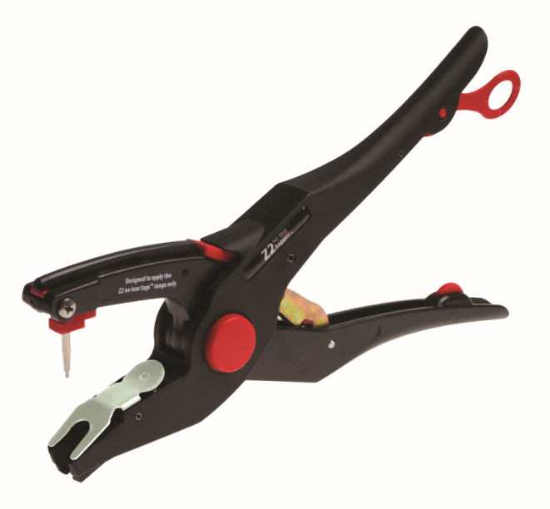

Technical Specifications

Dimension (when closed) | 270 mm x 65 mm x 33 mm
Dimension (when open) | 270 mm x 145 mm x 33 mm
Pin (Ø) | 3.5 mm
Weight | 315 g
Material | Polyamide PA6/Aluminium alloy
Product code | 700 2300-288

